

Semester One Examination, 2020

Question/Answer booklet

MATHEMATICS METHODS
UNIT 3

Section Two:

Calculator-assumed

Your Name:
Your Teacher’s Name:

Time allowed for this section
Reading time before commencing work: ten minutes
Working time: one hundred minutes

Materials required/recommended for this section
To be provided by the supervisor
This Question/Answer booklet
Formula sheet (retained from Section One)

To be provided by the candidate
Standard items: pens (blue/black preferred), pencils (including coloured), sharpener, correction fluid/tape, eraser, ruler, highlighters

Special items: drawing instruments, templates, notes on two unfolded sheets of A4 paper, and up to three calculators approved for use in this examination

Important note to candidates
No other items may be taken into the examination room. It is your responsibility to ensure that you do not have any unauthorised material. If you have any unauthorised material with you, hand it to the supervisor before reading any further.

Question | Marks | Max | Question | Mark | Max
8 |  | 5 | 15 |  | 9
9 |  | 12 | 16 |  | 10
10 |  | 5 | 17 |  | 10
11 |  | 11 | 18 |  | 7
12 |  | 4 | 19 |  | 6
13 |  | 8 | 20
14 |  | 6 | 21

Structure of this paper

Section | Number of questions available | Number of questions to be answered | Working time (minutes) | Marks available | Percentage of examination
Section One:  Calculator-free | 7 | 7 | 50 | 48 | 35
Section Two:  Calculator-assumed | 12 | 12 | 100 | 93 | 65
 |  |  |  | Total | 100

Instructions to candidates

- The rules for the conduct of the Western Australian Certificate of Education ATAR course examinations are detailed in the Year 12 Information Handbook 2019. Sitting this examination implies that you agree to abide by these rules.

- Write your answers in this Question/Answer booklet.

- You must be careful to confine your answers to the specific questions asked and to follow any instructions that are specific to a particular question.

- Additional pages for the use of planning your answer to a question or continuing your answer to a question have been provided at the end of this Question/Answer booklet. If you use the space to continue an answer, indicate in the original answer space where the answer is continued, i.e. give the page number.

- Show all your working clearly. Your working should be in sufficient detail to allow your answers to be checked readily and for marks to be awarded for reasoning. Incorrect answers given without supporting reasoning cannot be allocated any marks. For any question or part question worth more than two marks, valid working or justification is required to receive full marks. If you repeat any question, ensure that you cancel the answer you do not wish to have marked.

- It is recommended that you do not use pencil, except in diagrams.

- The Formula sheet is not to be handed in with your Question/Answer booklet.

Section One: Calculator-assumed (93 Marks)

This section has thirteen questions. Answer all questions. Write your answers in the spaces provided.

Spare pages are included at the end of this booklet. They can be used for planning your responses and/or as additional space if required to continue an answer.
● Planning: If you use the spare pages for planning, indicate this clearly at the top of the page.
● Continuing an answer: If you need to use the space to continue an answer, indicate in the original answer space where the answer is continued, i.e. give the page number. Fill in the number of the question that you are continuing to answer at the top of the page.

Working time: 100 minutes.

Question 8 (5 marks)

The position of an object at any time t (seconds) is given by $s\left(t\right)=3t^{4}-40t^{3}+126t^{2}-9$

- Determine when the object is at rest. (2 marks)

$$v\left(t\right)=12t^{3}-120t^{2}+252t=0$$
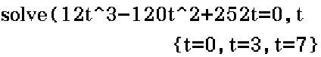

The object is at rest at 3 seconds and 7 seconds.

- State one correct answer
- State two correct answers

- Determine the distance (meters) travelled in the first 10 seconds. (3 marks)

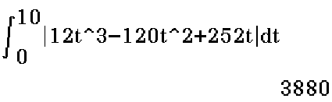

The distance travelled is 3880m

- Set up the correct integral with correct boundaries
- Use absolute value symbol or otherwise to solve for distance
- State the correct answer

Question 9 (12 marks)

The tide removes sand from a beach at a rate modeled by the function

$$R\left(t\right)=2+5 sin\left(\frac{4πt}{25}\right)$$

A pumping station adds sand to the beach at rate modeled by the function
$$S\left(t\right)=\frac{15t}{1+3t}$$

Both $R\left(t\right)$ and$S\left(t\right)$are measured in cubic yards of sand per hour, $t$is measured in hours, and the valid times are $0≤t≤8$. At time $t=0$, the beach holds 2500 cubic yards of sand.

- Find the total amount of sand the tide will be removed during the first 8 hours. Keep your answer in 2 decimal places.
(3 marks)
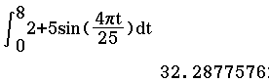

The total amount of the sand in the first 8 hours is 32.29 cubic yards

- Set up an integral of $R(t)$ with correct boundary points
- State the correct answer
- State the correct decimal places and units

- Show that the expression for $T\left(x\right)$, the total number of cubic yards of sand on the beach at time $x$ hours is$T\left(x\right)=2500+\int_{0}^{x}{\frac{15}{1+3t}-2-\sin\left(\frac{4πt}{25}\right)dt}$ (2 marks)

$$T\left(x\right)=2500+\int_{0}^{x}{S\left(t\right)-R\left(t\right) dt}=2500+\int_{0}^{x}{\frac{15}{1+3t}-2-\sin\left(\frac{4πt}{25}\right)dt}$$

- Set up an integral in terms of $S\left(t\right)-R\left(t\right)$
- Add the initial 2500 cubic yards

- Determine the instantaneous rate of the total number of cubic meters of sand on the beach at time $6$ hours. (3 marks)

$$T\left(t\right)=2500+\int_{0}^{t}{S\left(t\right)-R\left(t\right) dt}$$
$$T^{'}\left(t\right)=0+\frac{d}{dx}\int_{0}^{6}{S\left(t\right)-R\left(t\right) dt}=S\left(6\right)-R\left(6\right)=2.11 cubic yards/hr$$

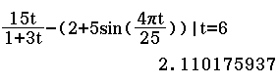

- Demonstrate the use of $T’(t)$
- Simplify the expression $S\left(6\right)-R\left(6\right)$ by F.T.C
- State the correct answer

- Over the time interval $0≤t≤8$, at what time the beach has the least amount of sand? What is this minimum value? Justify your answers fully. (4 marks)

$T '(t) = 0$ is when $S (t) – R (t) = 0$, i.e.$S \left(t\right)= R (t)$
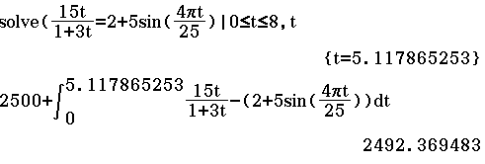

$$T^{''}\left(t\right)=\frac{d}{dt} S\left(t\right)-R\left(t\right)>0 as shown below$$
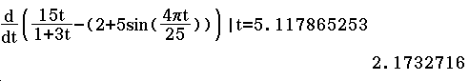

Therefore, the amount of sand is a minimum when $t ≈ 5.118$ hours. The minimum value is $2492.369$cubic yards.

- Equate 1st derivative to $0$
- Solve for $t$when $S (t) – R (t) = 0$
- Use 2nd derivative or otherwise to justify $T\left(t\right)$reaches minimum$t=5.118$
- State the correct minimum amount of sand

Question 10 (5 marks)

You are building five identical pens adjacent to each other with a total area of $1000m^{2}$, as shown in the following figure. Find the dimensions you should use to minimize the amount of fencing.
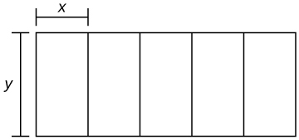

- Set up an expression for $p$(the total amount of fencing) in terms of $x$
- Determine the 1st derivative
- Equate the 1st derivative to 0 and solve for $x$
- Use 2nd derivative or otherwise to justify local minimum
- State the values for $x$& $y$ (or the total length & width) as the dimensions of the fencing.
Question 11 (11 marks)

The instantaneous velocity (m/min) of a moving object is given by the function $v$ as in the diagram below. Assume that on the interval $0≤t≤4$, $v\left(t\right)$ is given by $v\left(t\right)=-\frac{1}{4}t^{3}+\frac{3}{2}t^{2}+1$, and that on every other interval $v$ is piecewise linear, as shown.
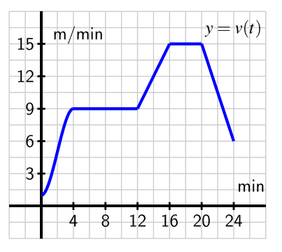
- Determine the exact distance travelled by the object on the time interval $0≤t≤4$.
(2 marks)
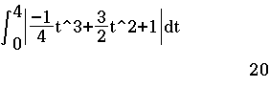setting out/answer
- Find the object's average velocity on $12≤ t ≤24$. (3 marks)
$$Total displacement=\frac{\left(4+8\right)\left(6\right)}{2}+\left(9\right)\left(8\right)+\frac{\left(6+15\right)\left(4\right)}{2}=150 m$$
Getting displacement, velocity = 150m/12mins = 12.5 m/min
- units
- Calculate the correct answer (2 marks)

- Find the time the object has the greatest acceleration and justify your answer. (4 marks)
$$When 0≤t≤4, a\left(t\right)=v^{'}\left(t\right)=-\frac{3}{4}t^{2}+3t$$
$$maximum at t=-\frac{3}{2\left(-\frac{3}{4}\right)}=2 min$$
$${a\left(2\right)=v}^{'}\left(2\right)=-\frac{3{\left(2\right)}^{2}}{4}+3\left(2\right)=3 m/\overset{2}{min}{2}$$
$$When 12≤t≤16, a\left(t\right)=\frac{15-9}{16-12}=2 m/\overset{2}{min}{2}$$
$$No need to consider 20≤t≤24 as it gives negative acceleration$$
$$Therefore the greatest accleation is at t=2$$

- Determine the expression for $a(t)$
- Use turning point formula or otherwise to determine $t=2$
- Compare $a\left(2\right)$ with the acceleration between $12≤t≤16$
- Conclude $t=2$

- Find the total distance travelled during the 24 minutes. (2 marks)

$$Total distance=20+72+150=242 m$$
$$setting\frac{out}{total}area$$
Question 12 (8 marks)

(a) A dangerous virus is slowly expanding forming a circular mass threatening to cover one side of a lake. What is the corresponding increase in area covered by the algae when the radius expands from $200 m$ to $200.5 m$? Use a calculus method to find your answer. (4 marks)

$$A=πr^{2} \\ \frac{dA}{dr}=2πr \\ δA≈\frac{dA}{dr}×δr≈2πr×δr \\ At r=200m, δr=0.5m \\ δA≈2π×200×0.5 \\ δA=200π≈628.3m^{2}$$

- Determine $\frac{dA}{dr}$
- Determine an expression for $δA$ in terms of $r$
- Substitute the correct $δr$
- Determine the correct $δA$

(b) A sector has radius r cm and angle θ radians. Given that its area $A$ is fixed, use calculus to find the approximate percentage change in its radius when its angle decreases by $2 \%.$ (4 marks)

- Determine an expression for $\frac{dr}{dθ}$
- Use incremental formula to obtain an expression for$δr$ in terms of $δθ$
- Substitute the correct expression for $δθ$
- Substitute the correct expression for $A$ and simplify to 1%

Question 13 (8 marks)
The new pesticide PET is being developed by CSIRO to inhibit the destruction caused by the Cane Toad The half-life of PET is approximately 12 years. Half-life is the time it takes for half of the amount of a substance to decay.

(a) If 100 grams/ha of PET was sprayed near the Western Australian/ Northern Territory Border in 2018, how long will it take to dissipate to 25 grams/ha?
(1 mark)

24 years

- State the correct answer

Let $A=100{\left(a\right)}^{t}$ represent the amount of PET left where$A$is in grams/ha of PET and
where $t$ is measured in years. Take $t=0$ in 2018.

(b) Find the value of $a.$ (2 marks)

$$A=100{\left(a\right)}^{t}$$
At $t=12,$ $50=100{\left(a\right)}^{12}$
$a=0.9438743127$

- Set up an equation by substituting $A=500, t=12$
- State the correct value for $a$

(c) Justify your answer to (a) using the equation$A=100{\left(a\right)}^{t}$. (1 mark)
$$Solve 25=100{\left(0.9438743127\right)}^{t},t)$$
$$t=24 years$$

- Substitute the correct values for $A$ and $a$

(d) If the PET reached acceptable levels to be almost harmless to Cane Toads when the 100 grams reduced to 1 gram, how long would this take to happen?
(2 marks)

$$Solve 1=100{\left(0.9438743127\right)}^{t}, t$$

$$t≈79.726 \text{years }$$

- State correct answers (2 marks)

(e) How much of the PET will remain on the land in 2050? (2 marks)

$$2050-2018= 32 years$$
$$A=100{\left(0.9438743127\right)}^{32}=15.749g/ha$$

- State correct answers (2 marks)

Question 14 (6 marks)

Suppose that $g$ is given by the graph below on the left and that $A\left(x\right)=\int_{1}^{x}{g\left(t\right)}dt$.

- Sketch a complete and accurate graph of $y=A\left(x\right)$ for $x≥1$on the axes provided on the right. Mark all turning points.
(4 marks)

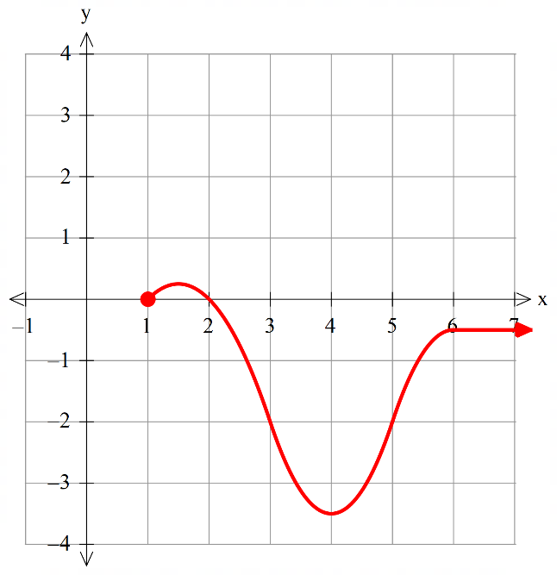
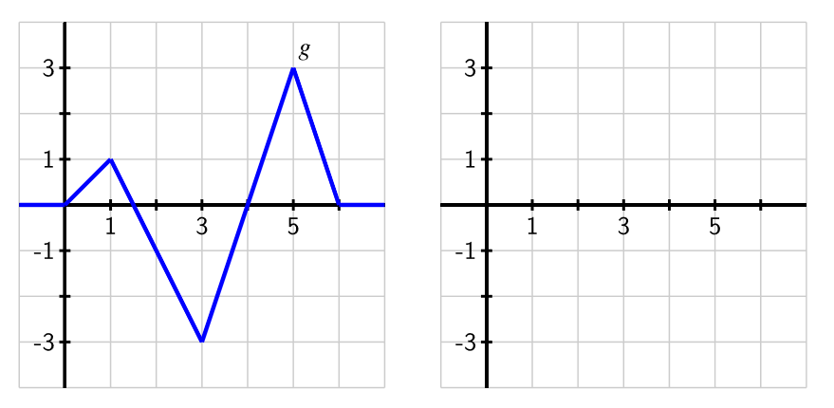
$$(2,0)$$
$$(4, -3.5)$$
$$(6,-0.5)$$
$$(1.5, 0.25)$$

- Mark one (of the above) correct turning point
- Mark two (of the above) correct turning points
- Starts from (1,0)
- Draw a correct shape overall

(b) How would the graph of $B\left(x\right)$ compare to $A\left(x\right)$ if $B\left(x\right)=\int_{0}^{x}{g\left(t\right)}dt$? (2 marks)

Vertically translate by $\frac{1}{2}$ units up

- Identify vertical translation
- Identify $\frac{1}{2} units$up

Question 15 (9 marks)

Let $X$ be a discrete random variable with domain only. Suppose the probability function of $X$ is given by
with a constant.
- Determine the probability distribution table and state the value of the constant . (3 marks)
$$X$$ | $$0$$ | $$1$$ | $$2$$ | $$3$$ | $$4$$
$$P(X=x)$$ | $$k$$ | $$\frac{k}{3}$$ | $$\frac{k}{9}$$ | $$\frac{k}{27}$$ | $$\frac{k}{81}$$
$$P(X=x)$$ | $$\frac{81}{121}$$ | $$\frac{27}{121}$$ | $$\frac{9}{121}$$ | $$\frac{3}{121}$$ | $$\frac{1}{121}$$
$$k+\frac{k}{3}+\frac{k}{9}+\frac{k}{27}+\frac{k}{81}=1, k=\frac{81}{121}$$
- Determine the table with correct expressions of $P(X=x)$
- Demonstrate the use of the sum of probabilities equal to 1
- Calculate the correct $k$
(b) Find $P\left(0<X≤2\right)$ (3 marks)
$$P\left(0<X≤2\right)=P\left(1\right)+P\left(2\right)=\frac{\frac{81}{121}}{3}+\frac{\frac{81}{121}}{9}=\frac{36}{121}$$
- Substitute the correct values for $k$
- Calculate the correct answer

(c) Determine and the standard deviation of . (3 marks)
$$X$$ | $$0$$ | $$1$$ | $$2$$ | $$3$$ | $$4$$
$$X^{2}$$ | $$0$$ | $$1$$ | $$4$$ | $$9$$ | $$16$$
$$P(X=x)$$ | $$\frac{81}{121}$$ | $$\frac{27}{121}$$ | $$\frac{9}{121}$$ | $$\frac{3}{121}$$ | $$\frac{1}{121}$$
$$E\left(X\right)=1×\frac{27}{121}+2×\frac{9}{121}+3×\frac{3}{121}+4×\frac{1}{121}=0.4793388$$
Standard deviation SCSA preferred method =
OR $SD\left(X\right)=\sqrt{Var(X)}=\sqrt{E\left(X^{2}\right)-{\left[E\left(X\right)\right]}^{2}}=\sqrt{0.8760331-{\left(0.4793388\right)}^{2}}=0.8039075$
- Determine the correct $E\left(X\right)$
- Determine the correct standard deviation
- Demonstrate working for both

Question 16 (10 marks)

90 Year 12 students are given five unevenly weighted coins that are more likely to land with the heads face up (heads-up). Each student flips their five coins and makes a note of the number of coins that land heads-up. The group tabulates their results below.

Number of heads-up coins | 0 | 1 | 2 | 3 | 4 | 5
Number of students | 1 | 1 | 3 | 10 | 32 | 43

- Using the results table above, determine
    - The probability that a randomly selected student observes no more than four heads
(1 mark)
$$P\left(X≤4\right)=\frac{47}{90}≈0.5\dot{2}$$
- Determine the correct answer

    - The mean number of heads observed per student (2 marks)

$$\overline{x}=\frac{38}{9}=4.\acute{2}$$

- Determine the correct answer

- Another student is given five coins to flip. Determine the probability that the student observes no more than 4 heads. You can assume that the number of heads that each student observes is binomially distributed with the above mean. (3 marks)
$$p=\frac{38}{9}÷5=\frac{38}{45}$$

$$Y\sim Bin \left(5,\frac{38}{45}\right)$$

$$P\left(Y≤4\right)≈0.5706$$

- Determine the correct $p$
- State binomial distribution with correct parameter
- Determine the correct probability

- Suppose it is known that 70% of all coins would land heads-up and that each student is now given 12 coins. Determine
- The probability that at least 7 coins will land heads-up for a randomly selected student. (2 marks)

$$Z\sim Bin\left(12, 0.7\right)$$

$$P\left(Z≥7\right)≈0.8822$$

- Determine the correct answer

- The probability that for 15 randomly selected students, exactly 10 students have at least 7 coins that land heads-up. (2 marks)

$$W\sim Bin\left(15, 0.8822\right)$$

$P\left(W=10\right)≈0.01945$

- Determine the correct answer

Question 17 (10 marks)
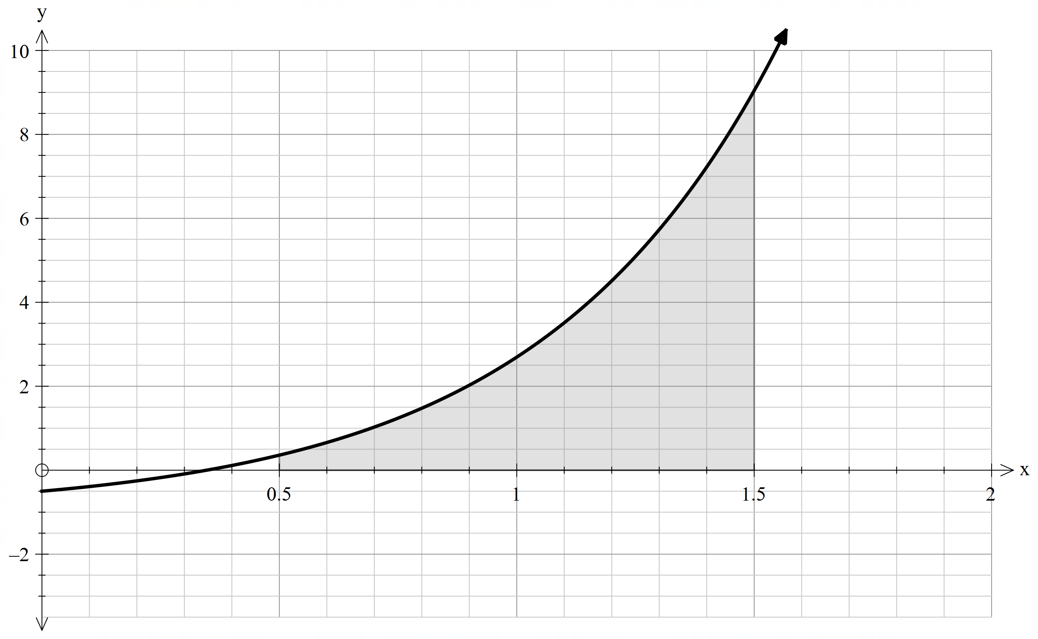The figure below shows a curve with equation $y=\frac{1}{2} \left(e^{2x}-1\right), x∈R$.

- Find an underestimate for the area of the shaded region using 4 intervals. (3 marks)
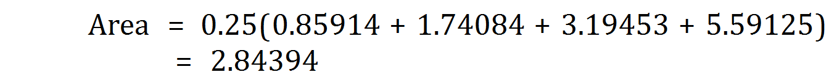
- 2 correct function values
- Correct width
- Answer

- Find an overestimate of the area of the shaded region using 4 intervals. (3 marks) 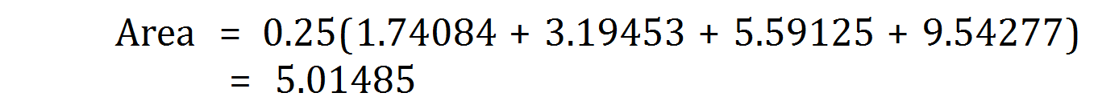
- 2 correct function values
- 4 correct function values
- Answer

- Using your answers in (a) & (b), determine a better estimate for the shaded region. (2 marks)

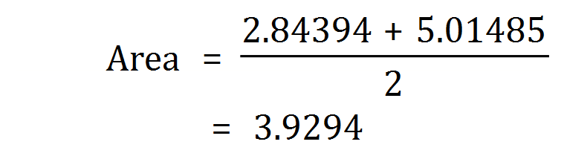
- Setting out
- Answer

- Is the estimate of the area in part (c) good enough? Discuss three different ways of improving this estimate. (3 marks)
Estimation can be improved by
(i) Use integral: The actual area is 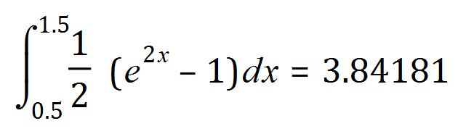
(ii) Reduce width of the rectangles

- State the estimation can be improved
- State one correct way
- State two correct ways

Question 18 (7 marks)

Sand is pouring out of a pipe such that the volume $V$ (in $m^{3}$) that has poured out after $t$ seconds is given by
$$V=0.216t$$
(where $M$ is the mass in kilograms of sand leaving the pipe and $t$ is the time in seconds since pouring began).
The sand forms a conical pile whose radius $r$ and volume $V$ are related by the equation
$$V=0.706r^{3}$$

a) Determine an expression for $r$ in terms of $V$. (2 marks)

$$r={\left(\frac{V}{0.706}\right)}^{\frac{1}{3}}=1.123V^{\frac{1}{3}}$$
- Rewrite $r$in terms of $V$
- Simplify the answer

b) Determine an expression for $\frac{dr}{dV}$. (2 marks)

$$\frac{dr}{dV}=\frac{1.123}{3}V^{-\frac{2}{3}}=0.374V^{-\frac{2}{3}}$$
- Obtain the 1st derivative
- Simplify the answer

c) Write down $\frac{dV}{dt},$ and hence use the chain rule to determine an expression for $\frac{dr}{dt}$ in terms of $V$.
(3 marks)
$$\frac{dV}{dt}=0.216$$

$$\frac{dr}{dt}=\frac{dr}{dV}\frac{dV}{dt}=\left(0.374V^{-\frac{2}{3}}\right)0.216=0.0808V^{-\frac{2}{3}}$$

- Determine $\frac{dV}{dt}$
- Demonstrate the use of chain rule
- Simplify the answer

Question 19 (6 marks)

A solid concrete wall has a cross section as shown below. The curve is given by the rule with , both are in metres. The wall is uniformly 15 cm thick
and of total length of 10 metres.

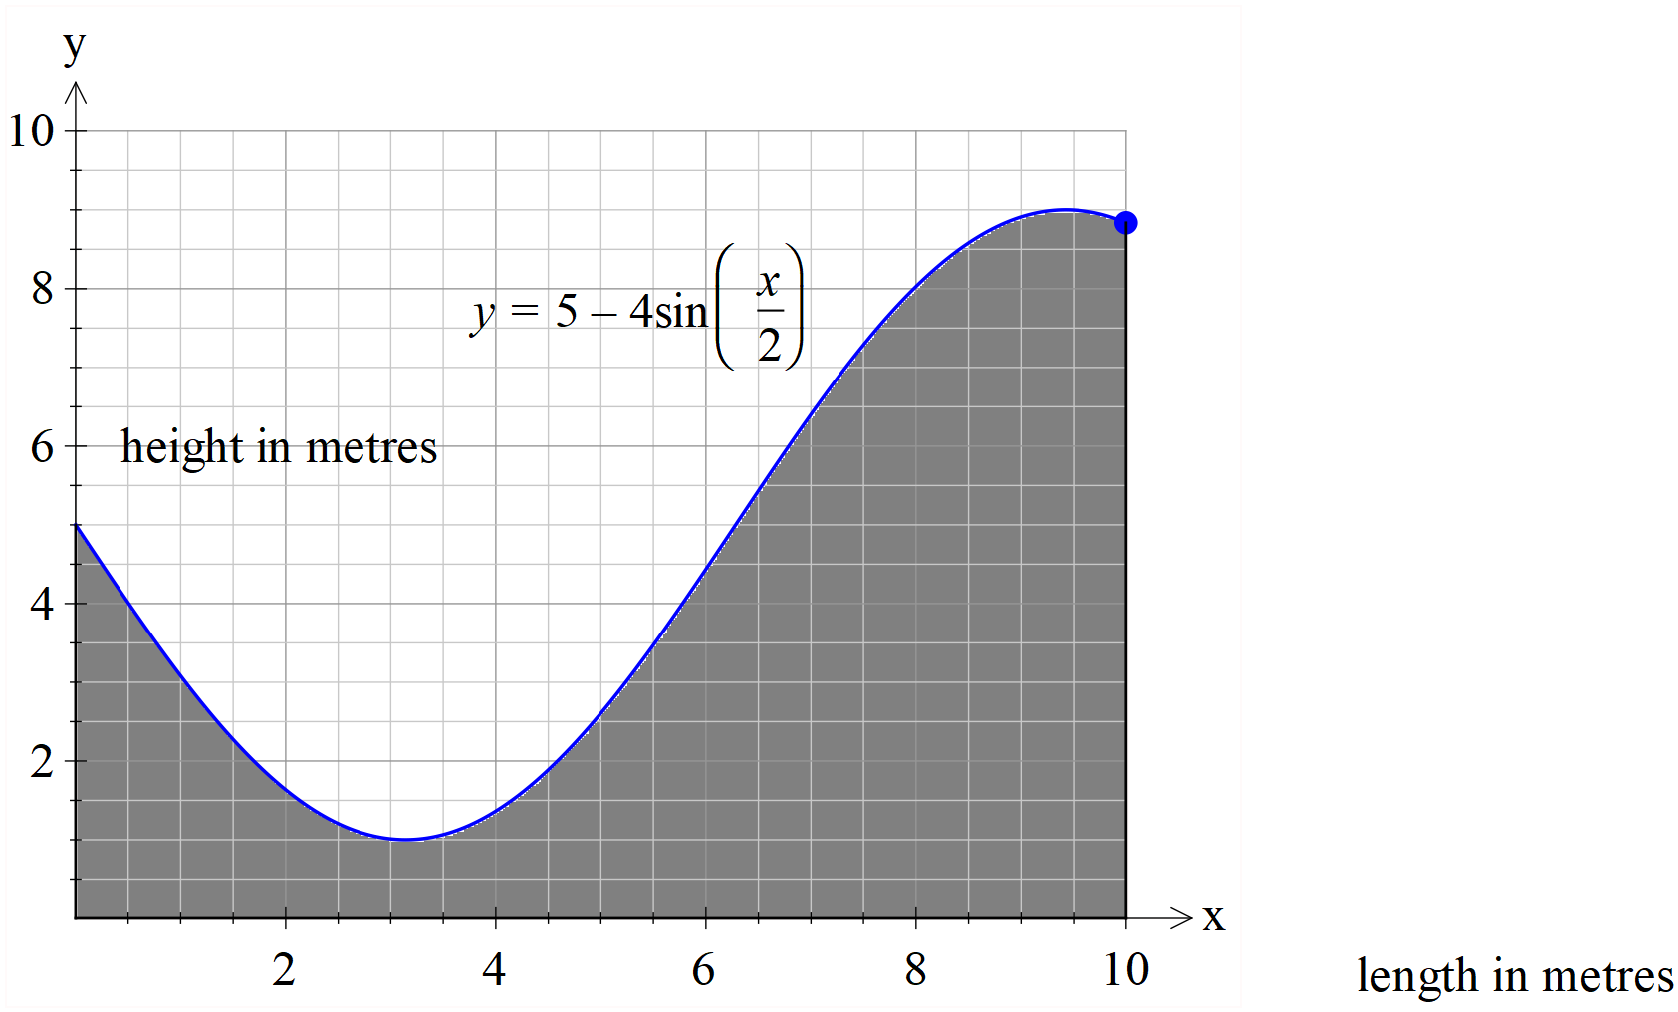

- Determine the coordinates of the turning points and any inflection points on the curve.

$$(3.1416, 1), (9.4248, 9), (6.2832, 5)$$
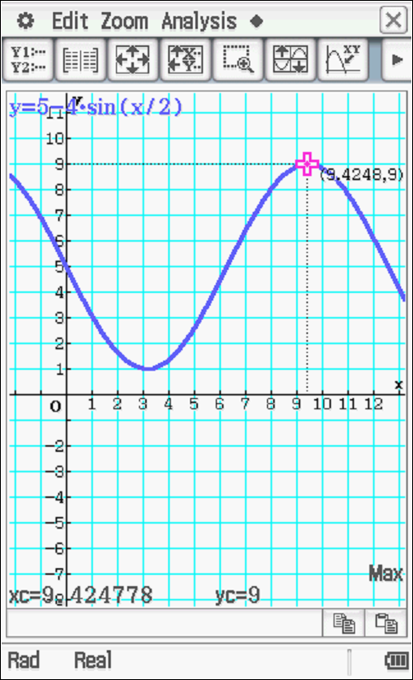
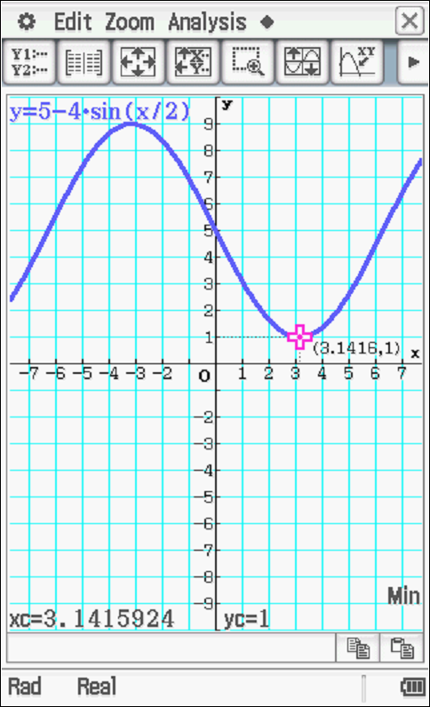

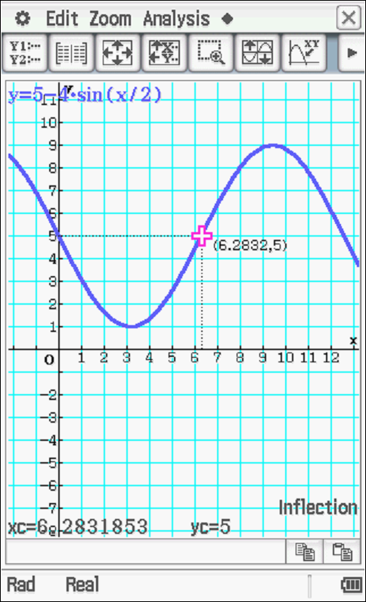

- Determine to the nearest cubic centimetre of concrete needed to make the wall.

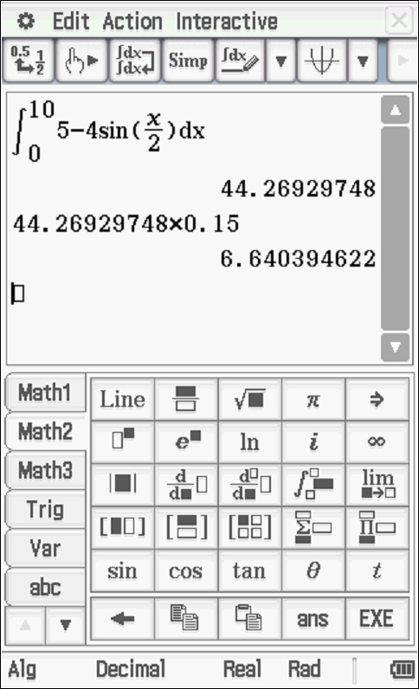

$$6.640395 m^{3} = 6640395{cm}^{3}$$

- Set up the integral
- Multiply the thickness 0.15m
- Determine the correct answer to the nearest cubic centimetre

Additional working space
Question number: _______

Additional working space
Question number: ________

Additional working space
Question number: ________

